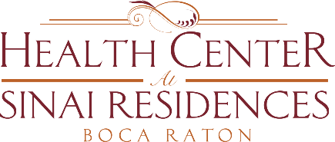

Health Center Broadcast Minutes
January 11, 2021

Update on Community COVID-19 cases: there are 2 positive employees in SNF, 2 in Assisted Living and 1 in Independent Living. There is 1 positive resident in Independent Living who is currently out of the community.
Vaccines will be administered on Thursday, January 14th to Assisted Living residents between 7:30am – 9:30am. Residents of the Health Center that received the 1st first dose, will receive their 2nd dose on January 18th.
Even after you received the vaccine, you must still wear your mask, wash your hands, social distancing. It is very important to continue doing all the above safety guidelines. It is about 2 weeks after the 2nd dose that you receive max immunity.

