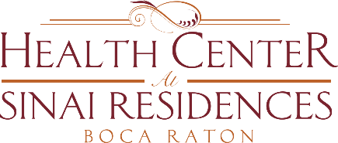

Health Center Broadcast Minutes
February 15, 2021

COVID-19 Community Census Update: 0 positive employee or resident cases across the community!
Reminder that even if you have received the second dose of the vaccine, you are still not at maximum immunity until weeks after receiving the 2nd dose. Continue to make smart decisions.
There are have been questions on when we will be able to provide the Vaccine to Private Aides. We are continuing to research having the vaccine offered through the Florida Department of Health. Once we have more information on administering here at Sinai we will provide the information to you.
Private Aides are eligible to receive the Vaccine through Publix just by being a Healthcare worker.

