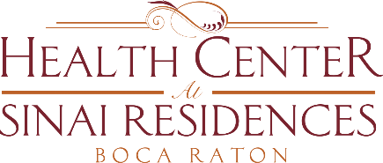

Health Center Broadcast Minutes
January 4, 2021

Update on Community COVID-19 cases: 6 positive employees in SNF and 3 employees in AL. There is one positive resident in IL.
Vaccine Update: we are working very closely with our account representative from Walgreens. We will provide an update as soon as we hear the date for Assisted Living and Memory Care Residents.
The Skilled Nursing Residents received their first vaccination on December 28th as this level of care prioritized by the Governor. The second round of this series will occur on January 18th.
Walgreens has indicated that they are focusing on the smaller communities first. The smaller communities are receiving their first dose sooner due to the number of vaccines that are available and the number of pharmacists that are required to be deployed to communities.
We received most Walgreens consent forms from AL residents. Please continue to complete and turn in.
The 3rd floor of Skilled Nursing is closed to visitors at this time.
Hotwire has implemented a new position – “educator”. This new position will assist with helping with Netflix or others items needed. More information to come.
Please refer to your Sinai Daily.

