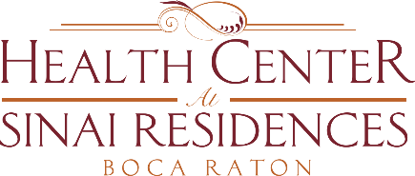

Health Center Broadcast Minutes
January 25, 2021

Vaccine Update:
The Vaccine will be offered to Private Aides. The priority was for residents first. The vaccine will be offered on Thursday, February 4th and Thursday, February 25th.
Have a conversation with your Private Aide to encourage them to receive the vaccine. We will provide further paperwork and communication with more details.
The 2nd dose for Assisted Living residents will occur on February 4th as well.
Update on Community COVID-19 cases: 1 in employee in Skilled Nursing and 1 employee in Assisted Living. There are currently two residents being safely cared for in the COVID-19 unit.
The Generator Load Testing is being tested tomorrow, Tuesday, January 26th at Noon with a brief disruption in a power outage.
There are many scam calls occurring lately. Do not answer or respond to any calls that may sound like a family member asking for money. There are many voices to manipulate voices in order to sound like a family member. These are scam calls.
Hang up immediately, call your grandson or granddaughter or the person asking. Do not provide any information or computer or iPhone passwords.
Voice Remotes from Hotwire Communication will be offered to residents. If you are interested in receiving a voice remote please reach out to the Concierge Desk at 561-609-4070 and staff can reach out to Hotwire on your behalf.

