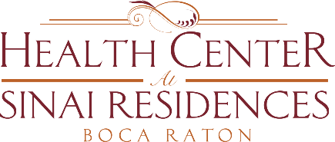

Health Center Broadcast Minutes
February 8, 2021

COVID-19 Community Census Update: 0 positive employee or resident cases across the community!
Reminder that even if you have received the second dose of the vaccine, you are still not at maximum immunity until weeks after receiving the 2nd dose. Continue to make smart decisions.
Please be mindful of scam calls. Many residents are continuing to receive calls, emails and even faxes with scam related requests. Please take a step back and verify with your family members before ever providing any information to them. Provided are numbers below to contact someone immediately if you receive fraudulent requests.
- AARP Fraud Helpline – 877-908-3360

- National Elder Fraud Hotline – 833-372-8311

We are continuing to work through determining what we can open again in the community. The earliest we would begin offering more items is March. Stay tuned for future updates.
Please refer to your SinaiDaily for daily programming and scheduling.

