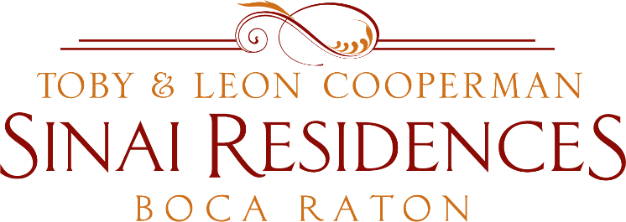

Live Broadcast Minutes
February 15, 2021

COVID-19 Community Census Update: 0 positive employee or resident cases across the community!
Please continue to keep doing the same to keep our numbers where they are today: social distancing, wearing a mask and continuing to wash hands.
The Walgreens program is coming to an end. There have been questions on when we will be able to provide the Vaccine to Private Aides. We are continuing to research having the vaccine offered through the Florida Department of Health.
Once we have more information we will provide the information to you.
Private Aides are eligible to receive the Vaccine through Publix just by being a Healthcare worker. Let them know you are an essential Healthcare worker. Once you make your first appointment, the system will automatically make an appointment for you.
This Thursday is our monthly Town Hall meeting on February 18th at Noon on Channel 909. We will provide many new updates on Dining, Visitor Policy.
Please continue to check to check the SinaiDaily for the latest schedules.

