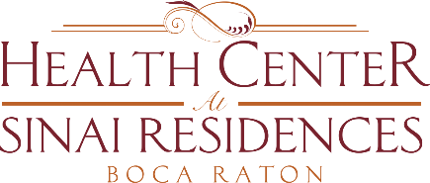

Health Center Broadcast Minutes
February 1, 2021

COVID-19 Community Census Update: One employee is positive in Skilled Nursing.
There are two residents in Skilled Nursing that tested positive. They have received a negative test.
Reminder that even if you have received either the first or second dose of the vaccine, you are still not at maximum immunity until weeks after receiving 2nd dose. Do not let your guard down. Continue to wash your hands, social distance and wear your masks at all times.
Residents that received the first dose will receive the 2nd dose this Thursday, February 4th.
For the Health Center, Private Aides, it is a first come, first serve basis to receive the vaccine for aides.
Also bring your vaccine cards with you to the 2nd dose. This Thursday, February 4th.

